NAME: KARTHIGA G SLOT: A
REG NO:192421383 SUB: CLOUD COMPUTING

EXP 2. FLIGHT RESERVATION SYSTEM (SaaS)
AIM
To develop a Flight Reservation System and deploy it as SaaS using Zoho Creator.
ALGORITHM
- Start
- Login to Zoho Creator
- Create application
- Create booking form
- Add passenger and flight details
- Create report
- Run application
- Enter booking details
- Display booking report
- Share application link
PROCEDURE
- Create application (FlightReservationApp)
- Create form (FlightBookingForm)
- Add fields: Name, Age, Gender, Flight No, Source, Destination, Date, Email
- Create report (FlightReport)
- Run application and enter data
- View booking details in report
- Share application link

OUTPUT SCREENSHOT
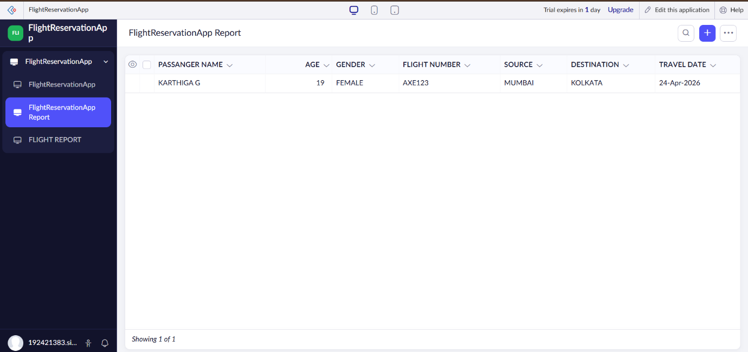

RESULT
A Flight Reservation System was successfully developed and deployed as SaaS using Zoho Creator.

